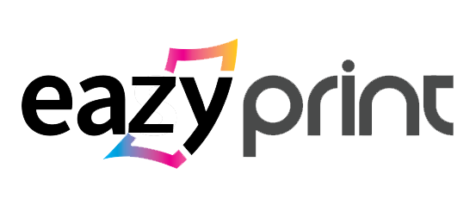

**FACEBOOK:** [**https://www.facebook.com/in.eazyprint/**](https://www.facebook.com/in.eazyprint/)

**WEBSITE :** [**www.eazyprint.in**](http://www.eazyprint.in) **(not live)**

**EMAIL : sales@eazyprint.in**

**Community/Sales Channel & Procedures:**

**Products:**

**Core Feature:**

1. **Artist/Designers**
2. **Dealers/Stores**

Dealer Special Price [E.g.: Profit + %on Sale amount]

–––––

Return to store

Logistics

If not satisfied

Refitting

Supplier

Return to Store

Return to Store

Instant Refund

Refund

Replace

Return Request to Store

[Within 5 days of delivery]

If satisfied

OK

Customer gets product

Option to choose as per delivery

Time-frame

Store gets commission

(After 7 days of delivery)

Logistic delivers to your Store

Check Suppliers

Order on-behalf of Customer

Customize/Upload Design

Customer visits Store

If not verified

If Verified

Dealer Regular Price.

[E.g.: Profit]

Store Verification

Login/Register

1. **Customer**

Pay

Create/ Choose Design

Login/Register

Choose Logistics

As per delivery time-frame

Choose Supplier

Rate our Service

If satisfied

Instant Refund after product received by Logistics

Refund

Order Complete

Logistic delivers from supplier to Customer

If not satisfied

Return Request (within 5 days of delivery)

Return to Logistics

Replace

Supplier gets paid after 7 days of delivery of product

If ordered from Artist/Designer Product. Artist/Designers gets Commission after 7 days of delivery

Refitting /Create new

Supplier by Logistics

1. **Suppliers**

Setup different prices for Dealers & Customers

See pending orders

Setup Category of Products that want to process

Approval Request to Eazyprint

Login/Register

If satisfied

Refitting /Create new

Supplier by Logistics

Return to Logistics

Instant Refund after product received by Logistics

Replace

Refund

Return Request (within 5 days of delivery)

Rate our Service

Customer receives product

Delivered by

Logistics

Approve processing of orders

If not

Satisfied

**Notes for each User-Flow**

**For Artist/Designers**:

* Payment would be released after 7 days of delivery.

**For Dealers/Stores**:

* Replacement or Refund should be allowed to process within 5 days of delivery.
* Payment Option instamojo, Payumoney, PayPal, etc.

**For Customers**:

* Replacement or Refund should be allowed to process within 5 days of delivery.
* Payment Option instamojo, Payumoney, PayPal, etc.

**For Suppliers**:

* 3 refunds or negative feedback can suspend your account.
* Branding materials of “**EAZYPRINT**” should be purchased from Eazyprint only.
* Banking information must be verified to activate your account and receive order
* Payment would be released after 7 days of delivery.